Posted 03/06/20113 at 2:09 pm by JAV

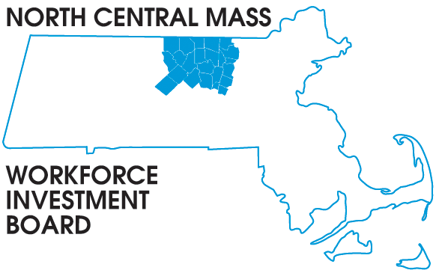
1355 Central Street Leominster, MA 01453 Phone: (978) 534 1023 Fax: (978) 534 1807

BOARD OF DIRECTORS MEETING

Tuesday March 12, 2012

North Central Chamber of Commerce
860 South Street Fitchburg, MA

8:00 a.m. –9:30 a.m.

AGENDA

Welcome & Introductions

New Members: Barbara Mahoney, Leominster Credit Union &
Linda Richelson, Fitchburg State University

Approve minutes of the November meeting (Vote required)
Executive Committee report: Martha C. (Vote required)

Director’s Report:

Job 1 Our Youth: Your Workforce Our Future (event feedback and discussion)

Presentations:

Paulette Carroll March 6th Job Fair report

Mark Wigler UI on Line

New Grant Opportunities:

Healthcare Workforce Transformation Fund RFP to be issued in June
Workforce Competitiveness Trust Fund grant submitted January 9th
@ Scale Higher Education STEM grant received January 1, 2013

Current Grants:

USDOL H1B, Youth Employer Engagement & Energy Sector Partnership

Other Business:
Chamber’s Economic Forecast event April 2nd Sheraton Four Points

